GlobeIce Coach Clip DOCX Slot Template
Use docx_slot keys to render timestamped coach clips into Word/PPTX packs.
Contract | Value | Use
Schema | {{SCHEMA_PATH}} | Canonical validation for coach clip exports.
Slot | {{CLIP_A1_DOCX_SLOT}} | Content-control/bookmark key for the clip block.
Review | avg_word_confidence < 0.55 or scene_score < 0.30 | Force human_review before publishing.
Publish | clip_confidence >= 0.62 and duration 6-240 s | Eligible only when rights are valid.

Clip Slot: CLIP_A1
Template rule
Replace the placeholders or bind the content controls by tag. Keep the docx_slot stable even if the visible title changes.

Field | Placeholder | Coach use
video_id | {{CLIP_A1_VIDEO_ID}} | Trace every note back to the source video.
clip_id | {{CLIP_A1_CLIP_ID}} | Stable clip row for review and rerendering.
start/end | {{CLIP_A1_START_ISO}} - {{CLIP_A1_END_ISO}} | Exact timestamp window.
duration_s | {{CLIP_A1_DURATION_S}} | Must be positive; publish window defaults to 6-240 s.
drill_type | {{CLIP_A1_DRILL_TYPE}} | Tags such as transition, forecheck, nz-regain.
intensity_rpe | {{CLIP_A1_INTENSITY_RPE}} | Coach load marker, 1-10.
reps | {{CLIP_A1_REPS}} | Detected or coach-entered repetition count.
season_phase | {{CLIP_A1_SEASON_PHASE}} | Preseason, inseason, playoffs, return_to_play, development.
lead_coach | {{CLIP_A1_LEAD_COACH}} | Responsible coach or reviewer.
provenance | {{CLIP_A1_PROVENANCE}} | Channel, upload date, and rights classification.

Confidence and Publication Gate
Signal | Placeholder | Decision
clip_confidence | {{CLIP_A1_CLIP_CONFIDENCE}} | >= 0.62 can auto-publish if all other gates pass.
scene_score | {{CLIP_A1_SCENE_SCORE}} | < 0.30 forces human review.
avg_word_confidence | {{CLIP_A1_AVG_WORD_CONFIDENCE}} | < 0.55 forces human review.
human_review | {{CLIP_A1_HUMAN_REVIEW}} | Derived by GlobeIce before publishing.
publish_state | {{CLIP_A1_PUBLISH_STATE}} | published or pending_review.
decision_reasons | {{CLIP_A1_DECISION_REASONS}} | Explain why the clip stopped in review.

Diagram Slot
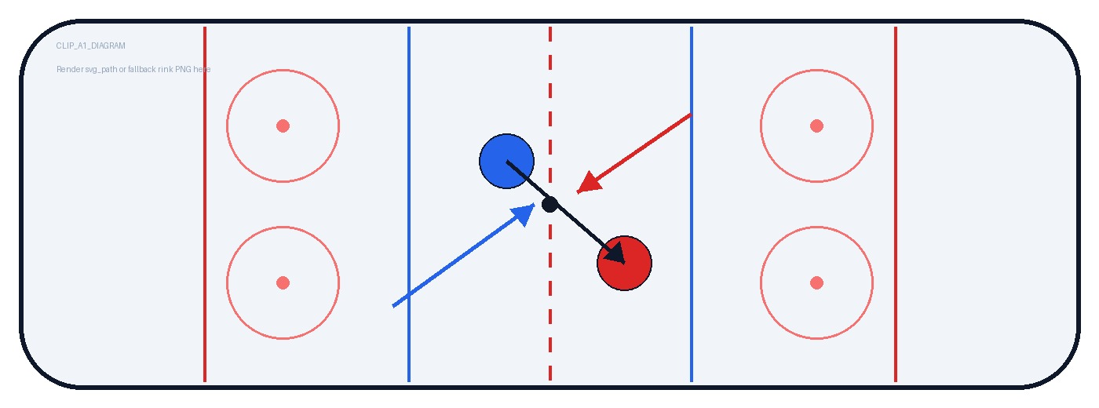
Diagram source: {{CLIP_A1_SVG_PATH}}

Low-Confidence Transcript Words
Token | Time | Confidence | Correction
{{CLIP_A1_LOW_WORD_1_TOKEN}} | {{CLIP_A1_LOW_WORD_1_T}} | {{CLIP_A1_LOW_WORD_1_CONF}} | {{CLIP_A1_LOW_WORD_1_FIX}}
{{CLIP_A1_LOW_WORD_2_TOKEN}} | {{CLIP_A1_LOW_WORD_2_T}} | {{CLIP_A1_LOW_WORD_2_CONF}} | {{CLIP_A1_LOW_WORD_2_FIX}}
{{CLIP_A1_LOW_WORD_3_TOKEN}} | {{CLIP_A1_LOW_WORD_3_T}} | {{CLIP_A1_LOW_WORD_3_CONF}} | {{CLIP_A1_LOW_WORD_3_FIX}}

Coach Review Checklist
Done | Check | Notes
 | Label matches video | {{CLIP_A1_LABEL_REVIEW_NOTES}}
 | Timestamp starts and ends cleanly | {{CLIP_A1_TIMECODE_NOTES}}
 | Diagram supports the teaching point | {{CLIP_A1_DIAGRAM_NOTES}}
 | Rights allow selected publish target | {{CLIP_A1_RIGHTS_NOTES}}
 | Player-safe playlist wording approved | {{CLIP_A1_PLAYER_SAFE_NOTES}}

Renderer Mapping
Slot key | Content control tags
CLIP_A1 | All tags prefixed with CLIP_A1_ belong to the first clip block.
CLIP_B1 | Duplicate this section and replace CLIP_A1_ with CLIP_B1_ for the next row.
TITLE / NOTES | Use top-level tags for pack metadata and coach notes.

